Fast**National University of Computer & Emerging Sciences, Karachi  
Spring-2019 CS-Department  
Midterm I  
February 28, 2019 Slot: 11 AM – 12 NOON**

|  |  |  |
| --- | --- | --- |
| **Course Code: CS 401** | **Course Name: Artificial Intelligence** | |
| **Instructor Name: Rauf Shams Malik / Saeeda Kanwal / Nida Pervaiz** | | |
| **Student Roll No:** | | **Section No:** |

* Return the question paper.
* Read each question completely before answering it. There are **3 questions and 2 pages.**
* In case of any ambiguity, you may make assumption. But your assumption should not contradict with any statement in the question paper.
* All the answers must be solved according to the sequence given in the question paper.
* Be specific, to the point while coding, logic should be properly commented, and illustrate with diagram where necessary.

**Time**: 60 minutes. **Max Marks**: 50 points

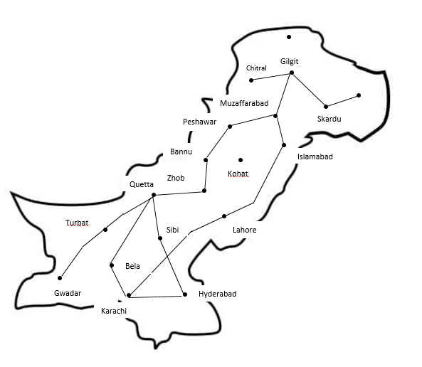

|  |
| --- |
| **Question No. 1 [Time: 30 Min] [Marks: 20]** |

1. Wajahat was going on a Pakistan tour trip with Fastians but due to his over egoistic attitude Fastians intentionally have left him just to teach him a nice lesson. Now his task is to reach from Karachi to the peaks of Gilgit via road trip using the map provided below. He has got a lucky friend like you who will run BFS and DFS both; and will then tell him which algorithm is better. Tell the search nodes first and then tell the pathway (together with path cost) followed using both the strategies. [12]
2. You have been given a 3x3 grid in which there is one blank tile existing. The blank tile has this restriction that it can only swap itself with any of its diagonal tile. The heuristic function is H(n)= no. of tiles out of their place which they should obtain in goal state. For eg in initial state we can see number 4, 1 and 8 are not in their correct places as per goal state to acquire so number of tile out of place=3 for initial state. Your task is to construct entire search space until goal state is reached and then by running A* show which states will be visited by the algorithm. Circle those states which will be visited by A*. Show clear working of how you select states based on A*. [8]

|  |  |  |
| --- | --- | --- |
| 3 | 4 | 5 |
| 1 | 2 | 8 |
| 7 | - | 6 |

|  |  |  |
| --- | --- | --- |
| 3 | 1 | 5 |
| - | 2 | 4 |
| 7 | 8 | 6 |

Initial State Goal state

|  |
| --- |
| **Question No. 2 [Time: 10 Min] [Marks: 10]** |

1. Sudoku is a logic-based number placement puzzle. The objective is to fill a 9x9 grid so that each column, each row, and each of the nine 3x3 boxes contains the digits from 1 to 9. Each digit can only appear once per column, row, and 3x3 box. A sample Sudoku puzzle to use for this question is given in the figure below.

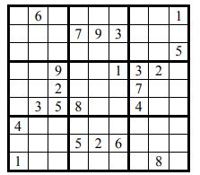A)  Classify the characteristics of the environment for Sudoku according to the following properties and explain the analyzed reason for each of your five choices [7.5]

• Fully observable/partially observable

• Deterministic/stochastic

• Episodic/sequential

• Static/dynamic/semi-dynamic

• Discrete/continuous

B) Specify the task environment of Sudoku puzzle? [2.5]

|  |
| --- |
| **Question No. 3 [Time: 15 Min] [Marks: 20]** |

1. We have 6 taxis’ and 3 passengers who have to be assigned taxi as per some attributes. Following are taxi’s performance value initially.

|  |  |
| --- | --- |
| TAXI | PERFORMANCE VALUE |
| 1 | 25 |
| 2 | 20 |
| 3 | 15 |
| 4 | 10 |
| 5 | 2 |
| 6 | 2 |

With regard to the passengers’ information now, so we have 3 passengers namely Alice, Ben and Joseph. Alice is one of the most amazing client thereby we say that whichever taxi Alice chooses, its performance value will get doubled. Ben is just an average client thereby whichever taxi Ben chooses; its performance value will remain as default value (no change in value thereby). Lastly Joseph is the worst client one can ever have, thereby whichever taxi he will choose, its performance will get into half the default value (take floor of the value if it’s coming in decimal).

Your task is now to simulate a dry run of genetic algorithm on this case running for 3 iterations. Choose an initial population of four. Next apply fitness function to your problem. Choose best three subsequently. Decide crossover point and then apply mutation. For mutation we have been told that chances of mutations are: 200 mutations in 100 generations.